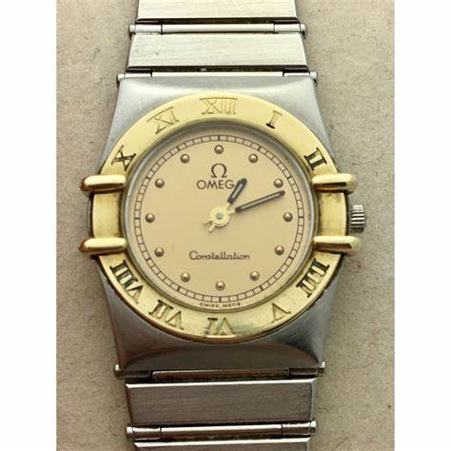Omega

Description: Omega offers a stunning collection of women’s watches that blend Swiss precision, timeless design, and modern innovation. Known for their heritage in space exploration, deep-sea diving, and luxury watchmaking, Omega’s women’s timepieces cater to both elegance and performance.

One of the most iconic collections is the **Omega Constellation**, instantly recognizable by its signature **"Griffey" (claws)** and Roman numeral bezel. Available in stainless steel, gold, and diamond-set variations, the Constellation offers both quartz and automatic movements, with exquisite dials in materials like mother-of-pearl, sunburst, and aventurine. For women who appreciate a versatile yet luxurious timepiece, this collection is a perfect choice.

The **Omega De Ville** collection embodies classic elegance, featuring refined round cases, slim profiles, and intricate details such as diamond hour markers and two-tone gold designs. Available in the **Prestige** and **Trustor** lines, De Ville watches cater to those who prefer a timeless and sophisticated look, with options in both quartz and Co-Axial automatic movements.